**Initializing the Four Coffee Pots:**

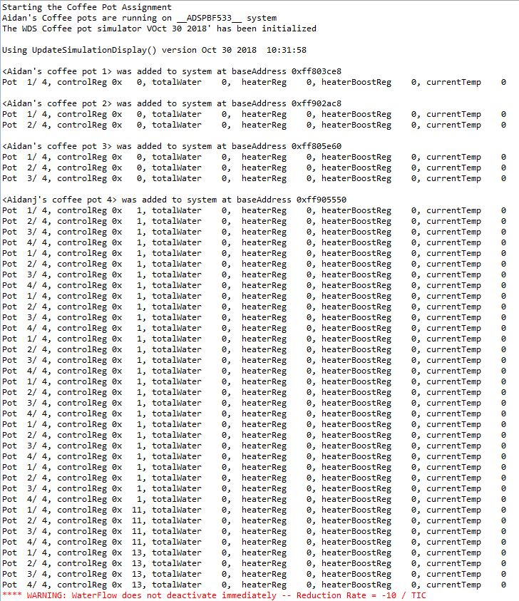

**Activating the LED Control, Water Control and Heat Control as well heating and filling the Coffee Pot:**



**Showing Water Evapouration and placing the Coffee Pod into the Coffee Pot:**



**Showing the Print Outs of the Coffee Pots after a Long Period of Time:**

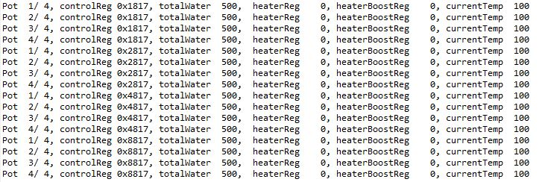

**Picture of the Four Coffee Pots Boiling with a Coffee Pod:**

